1. site for its current customers and prospects. 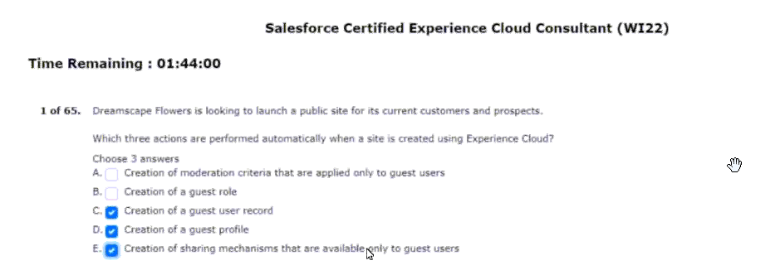
2. Salesforce cms via a cms collection in its customer portal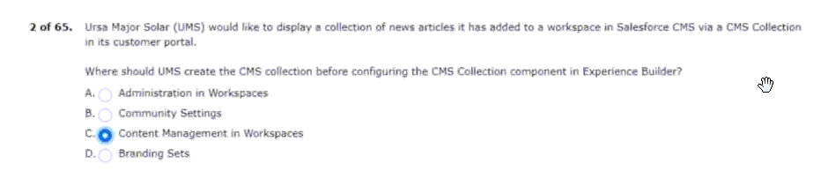
3 they are not getting the desired results. 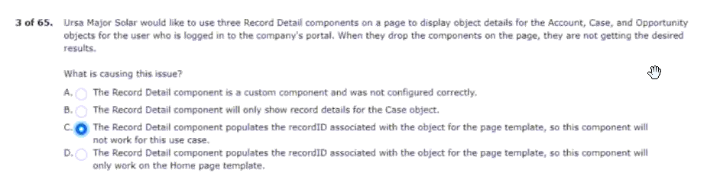
4 making updates to its experience cloud site.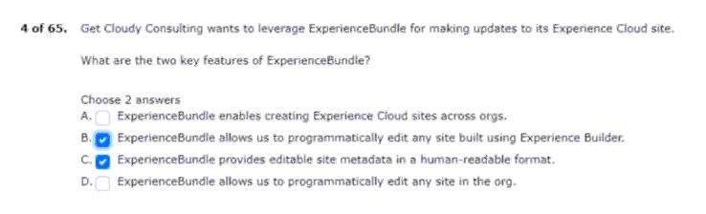
5 when users search for keywords in its customer portal.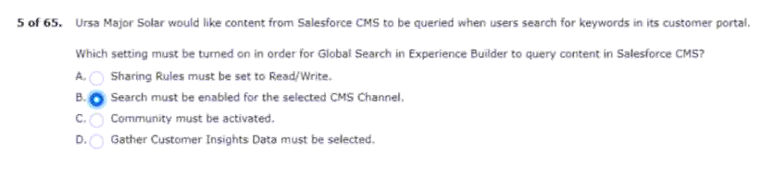
6 this capability for experience cloud site users as well.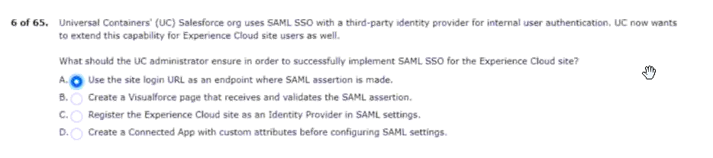
7 include a promotion for participating in the community.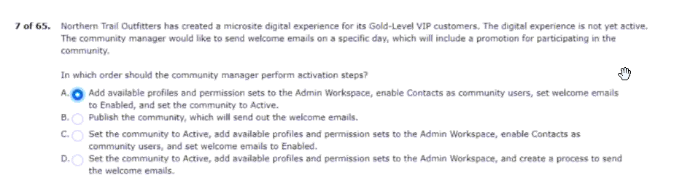
8 the lead converted into an opportunity.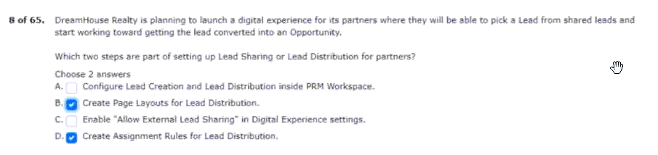
9 supports channel sales, lead distribution, and deal registration.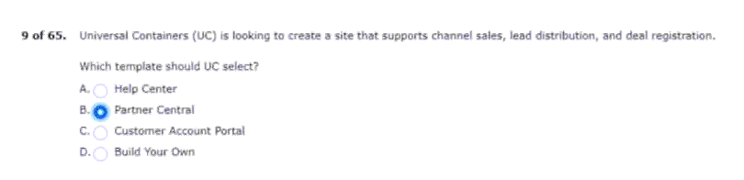
10 questions and answer other users questions on the site.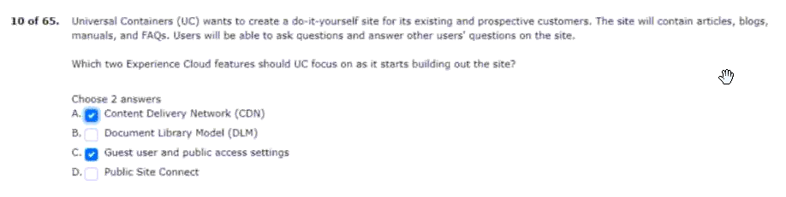
11 ok will be using content delivery network (cdn).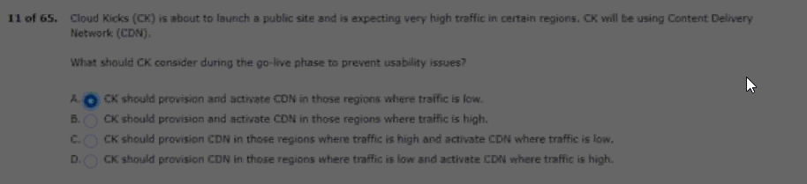
12.for setting up partner roles in large orgs?
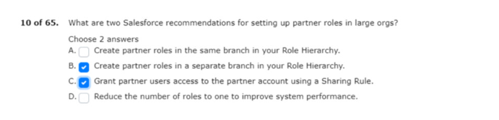

13. The admin is not able to create it from the contact record 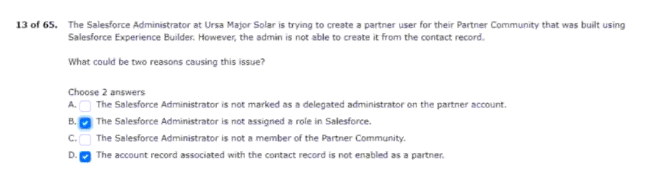
14 getting useful insights on adoption and engagement. 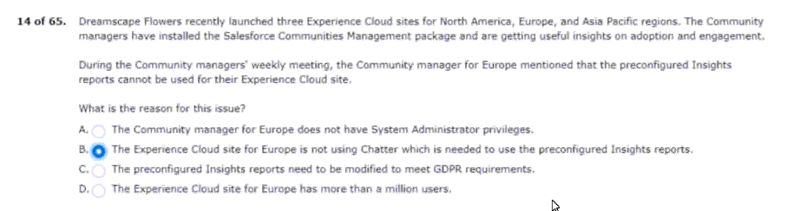
15 visibility can be controlled by using which functionality?.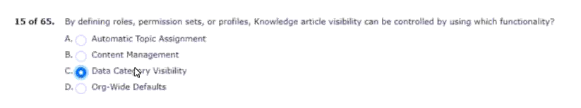
16 the newly experience cloud site however, the import failed. 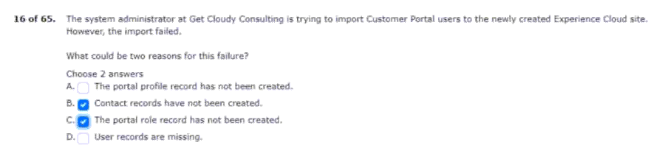
17 articles as a self-service option to troubleshoot issues.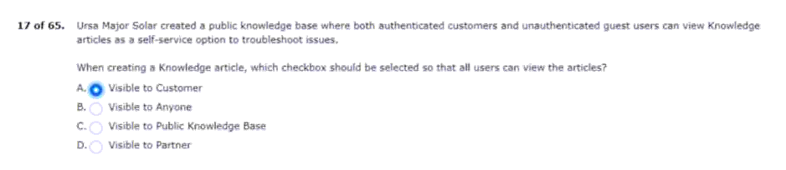
18 owned by their peers and subordinates.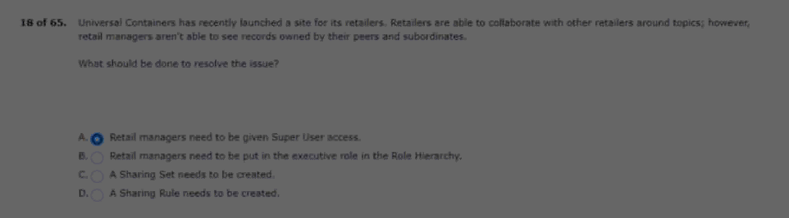
19 them to log in to the site to access any information.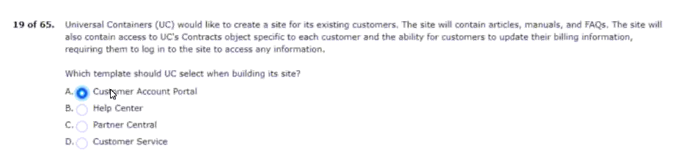
20 planning to use content delivery network (cdn).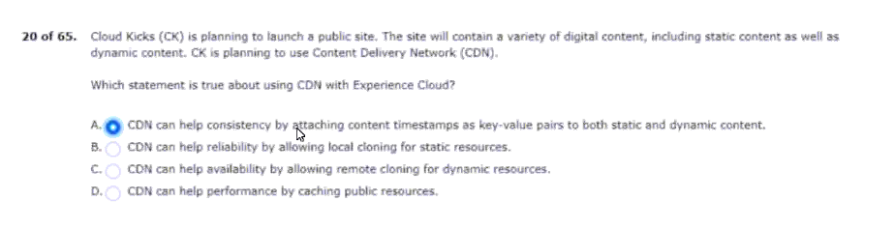
21 by customer community users be shared with internal users?. 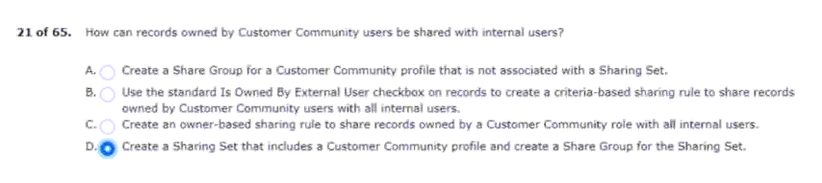
22 created for a custom eventregistration object.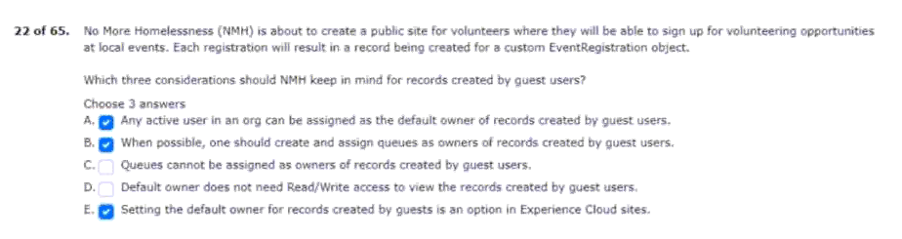
23 create a new partner user for an existing site.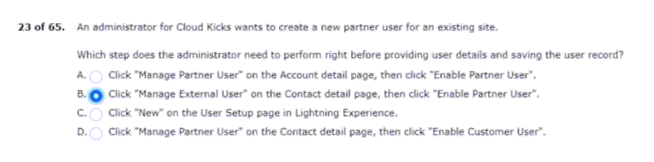
24 other researchers on their research work.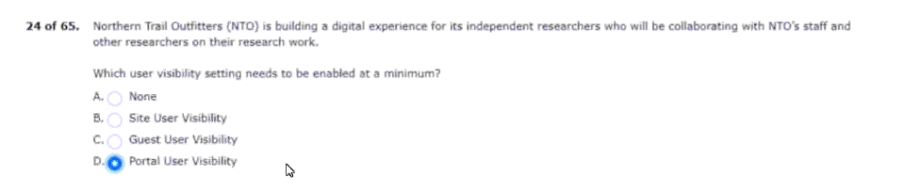
25 component assigned solely to platinum customers.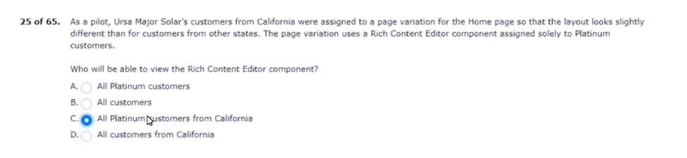
26 the user records of the internal users as well.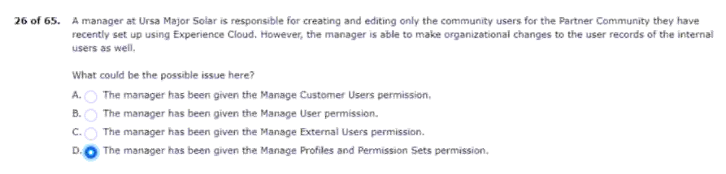
27 users can easily search and browse for information.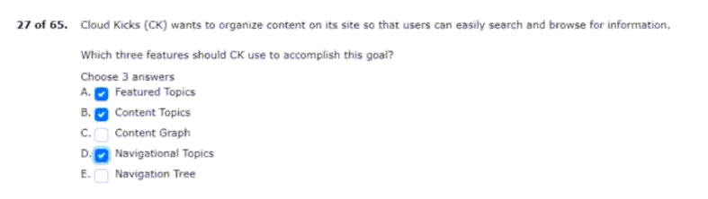
28 users will be assigned a partner community license and a role.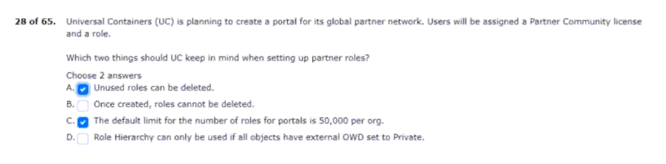

29 permissions are included for a delegated administrator?.
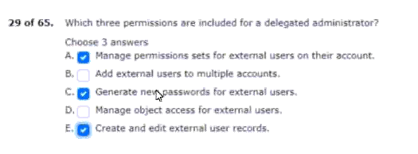
30 the completion of an experience cloud site setup?.
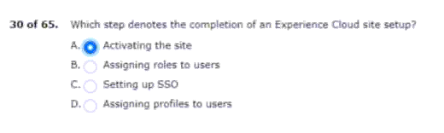
31 being able to service the customer.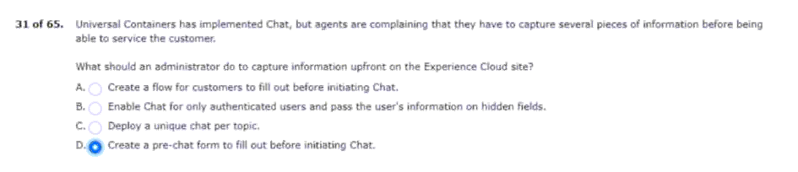
32 its current channel sales performance.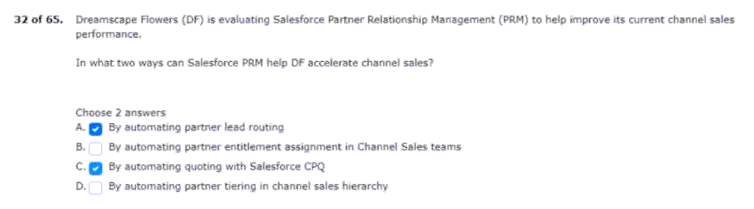
33 onboard three new partners to the community.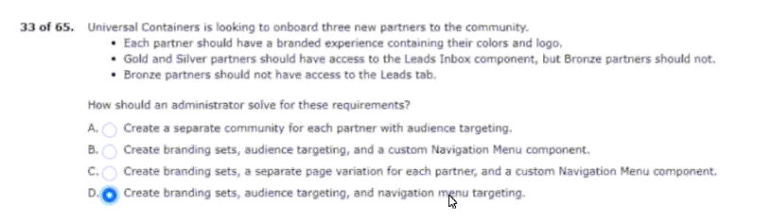
34 able to view articles, manuals, and faqs.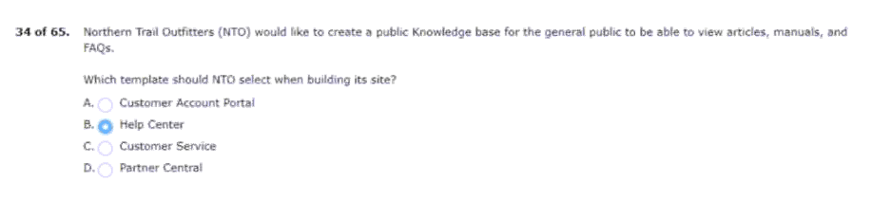
35 must not be shared with the general public.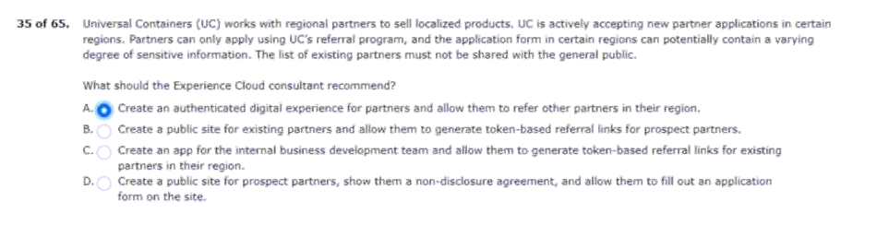
36 experience cloud site is visible to search engines.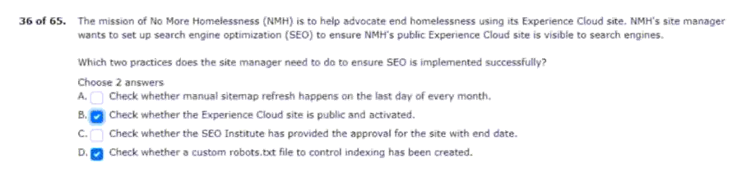

37 and customer community plus license for the customers.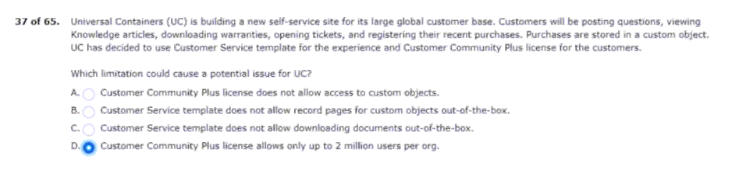
38 setting up similar communities based on df’s approach.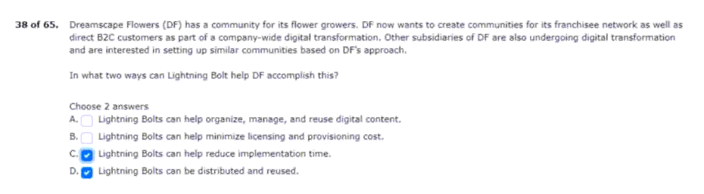
39 using standard profiles for external users.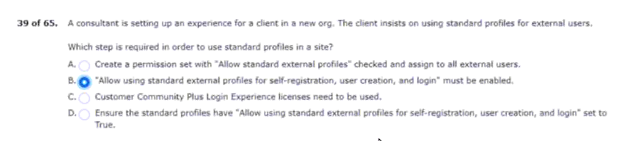
40 those knowledge articles available to site users.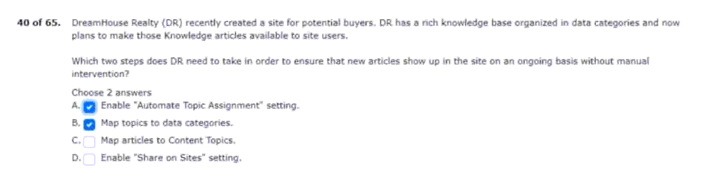
41 solar is creating an employee experience portal.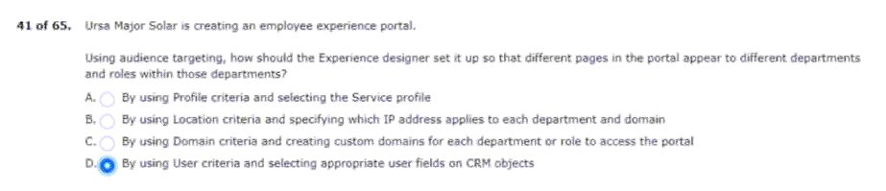
42 cases, download ndas, and create dashboards.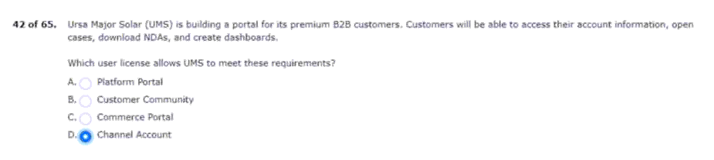
43 that is assigned only to the legal department audience.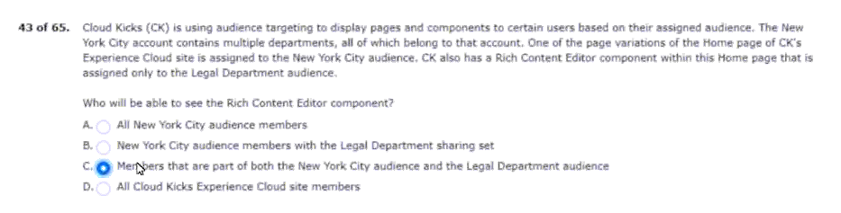
44 that meets the following requirements.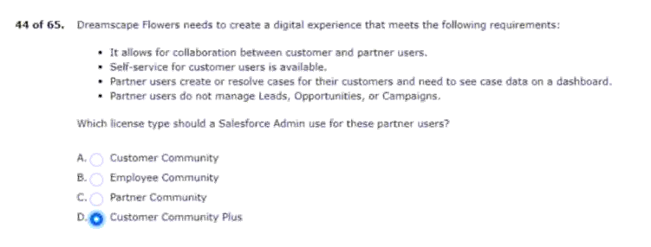
45 and is now reaching unmanageable levels.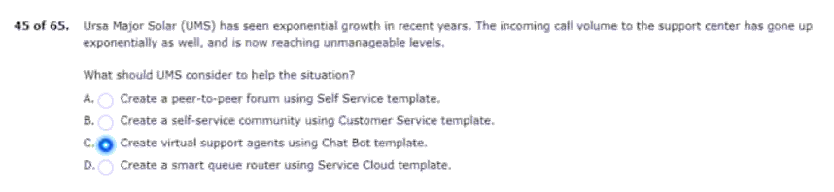
46 calls to its support line are for repeatable issues.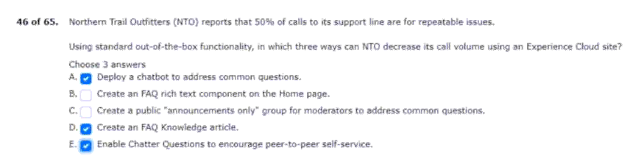
47 the lead record should not be shared with partners.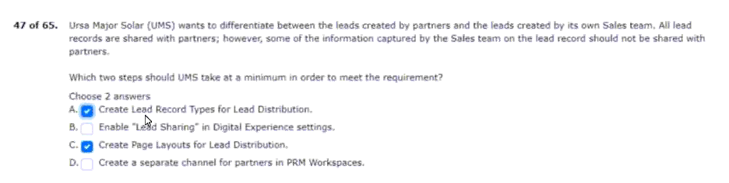
48 that link to standard and custom objects.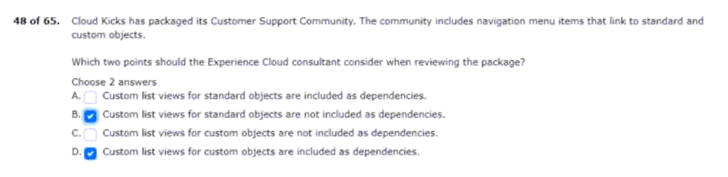
49 bolt solutions for employees at a world tour event.
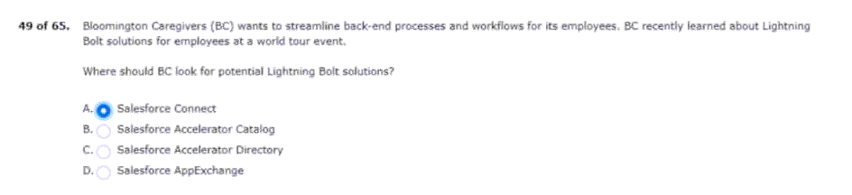
50 dreamhouse realty (dr) and cloud kicks (ck).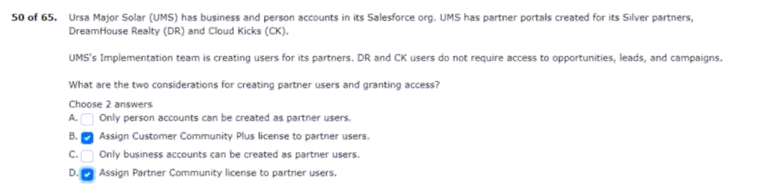
51 with uc to convert them into sales.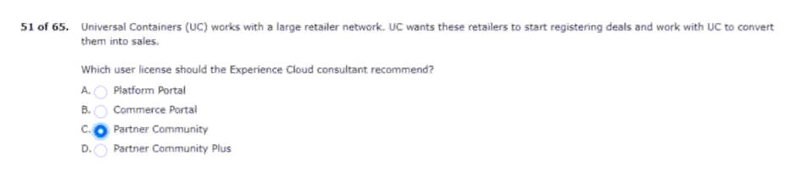
52 nto has customer community plus licenses.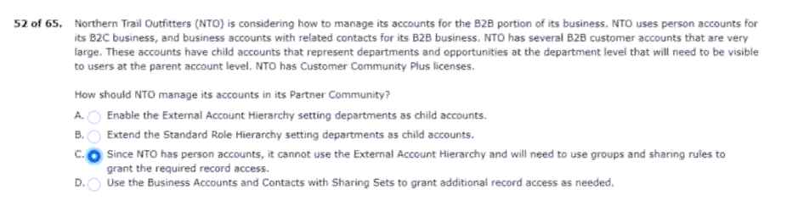
53 opportunities with a community user be shared?.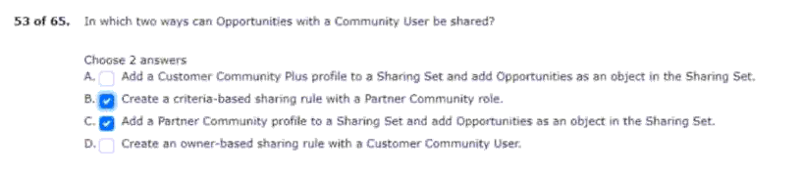
54 with custom tags or member-created topics.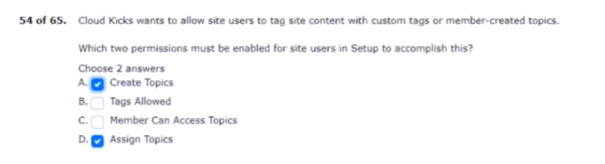
55 universal containers is implementing a partner community.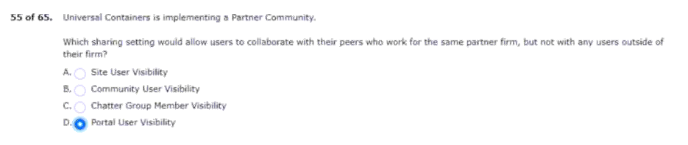
56 view access to cases created by their child companies.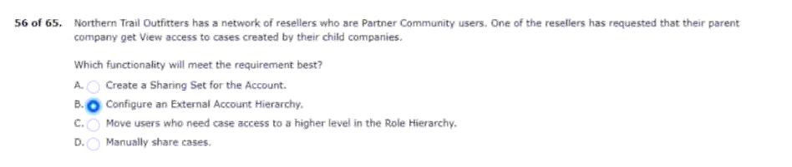
57 be able to approve installation projects and deals.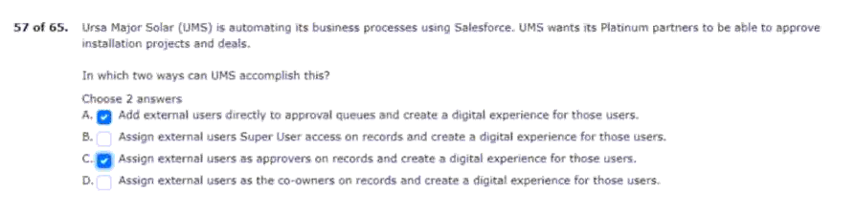
58 partner user from an enabled partner account?.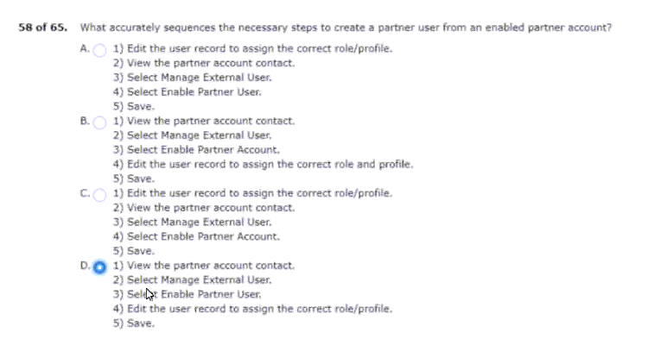
59 .for its domain, which ck is planning to change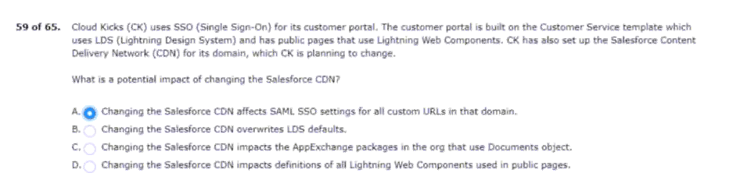
60 configuring self-registration for an experience cloud site?.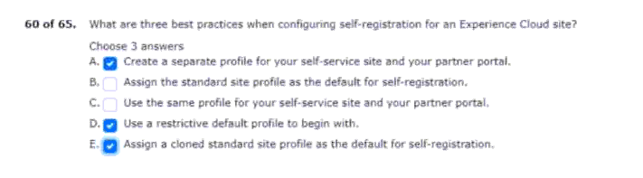
61 ways a question can be escalated to a case?.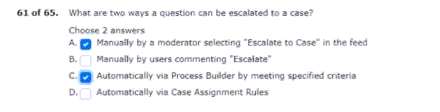
62 make an external; user a site moderator.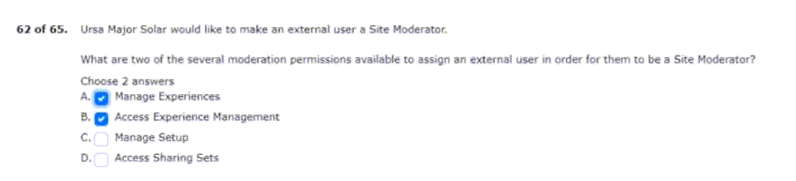
63 but not opportunity or asset objects.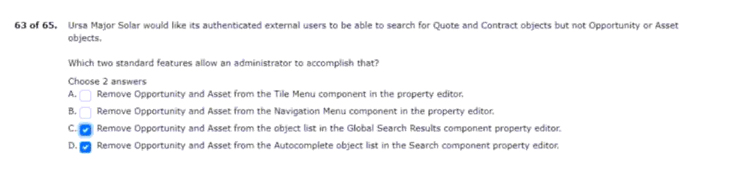
64 users are unable to see images on its customer portal.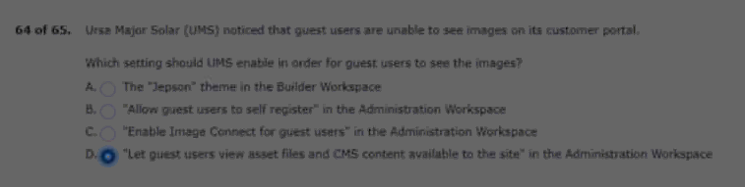

65 the sites are built with experience cloud site templates.
